MoodFlick
Emotion-Based Movie Recommendation
A Facial Emotion Recognition and Mood-Aware Film Recommendation Platform

[ Insert University Logo Here ]

Submitted By:
Aleeza
Registration No. ______________
[ Team Member 2 Name ]
Registration No. ______________
[ Team Member 3 Name ]
Registration No. ______________

Supervised By:
Sir Amish Hassan

DEPARTMENT OF TECHNOLOGY

THE UNIVERSITY OF LAHORE
Fall 2023 – Spring 2027

MoodFlick
Emotion-Based Movie Recommendation Platform

A thesis submitted in partial fulfilment of the requirements
for the Degree of Bachelor's in Information Engineering
at The University of Lahore, Lahore
Supervisor | Co-Supervisor
Name: Sir Amish Hassan | Name: ____________________
Signature: ____________________ | Signature: ____________________
Evaluator 1 | Evaluator 2
Name: ____________________ | Name: ____________________
Signature: ____________________ | Signature: ____________________
In charge, Project Cell IET | Convener, Project Cell
Name: ____________________ | Name: ____________________
Signature: ____________________ | Signature: ____________________

Head, Department of Technology:
Signature: ____________________

DEPARTMENT OF TECHNOLOGY
THE UNIVERSITY OF LAHORE
Spring, 2025

DECLARATION
We, AleezaZubair, SeharMehmood and AneebBaari , hereby declare that the work presented in this Final Year Project titled "MoodFlick: Emotion-Based Movie Recommendation" is our original work carried out under the supervision of Sir Amish Hassan in the Department of Technology, The University of Lahore.
This thesis has not previously been submitted, either in whole or in part, for the award of any degree or diploma at this or any other educational institution.
We further declare that all sources of information, ideas, figures, and published material used in this thesis have been properly acknowledged through appropriate citations and references. Every effort has been made to ensure that this work does not violate any copyright or intellectual property rights.
We understand that the University reserves the right to use plagiarism detection software to verify the originality of this thesis.

Student Name
Aleeza
Signature: ____________________
Date: ____________________

[Team Member 2 Name]
Signature: ____________________
Date: ____________________

[Team Member 3 Name]
Signature: ____________________
Date: ____________________

PREFACE
This thesis presents the design and development of MoodFlick, an intelligent web application that recognises a user’s facial expression in real time and recommends films that match the detected mood. The project was developed as a Final Year Project in the Department of Technology at The University of Lahore.
The project focuses on combining computer vision and deep learning with modern web technologies. A Convolutional Neural Network (CNN) trained on the FER-2013 dataset classifies a face into one of seven emotions, and a mood-mapping engine translates that emotion into a curated shelf of movie recommendations. The application also exposes a raw emotion detector, a per-class confidence breakdown, a watchlist, and a lightweight mobile companion.
Throughout the development of this project, we gained practical experience in image preprocessing, CNN design and training with TensorFlow/Keras, real-time inference with OpenCV, back-end development using the Flask framework, responsive front-end development with HTML, CSS, and JavaScript, and software engineering methodologies.
This project significantly enhanced our understanding of affective computing, deep learning, real-time computer vision, full-stack web development, system design, teamwork, and problem solving.

ACKNOWLEDGEMENT
All praise and gratitude are due to Almighty Allah, whose countless blessings, guidance, and mercy enabled us to successfully complete this Final Year Project.
We would like to express our sincere gratitude to our respected supervisor, Sir Amish Hassan, for his continuous encouragement, valuable guidance, constructive criticism, and unwavering support throughout every phase of this project. His experience and mentorship played a vital role in improving the quality of our work.
We are also thankful to all the faculty members of the Department of Technology, The University of Lahore, whose knowledge and guidance throughout our academic journey laid the foundation for completing this project successfully.
Special appreciation goes to our classmates, friends, and family members for their continuous motivation, encouragement, and moral support during the development of this project. Finally, we would like to thank everyone who directly or indirectly contributed to the successful completion of MoodFlick.

ABSTRACT
Choosing what to watch has become increasingly difficult as streaming catalogues grow, and conventional recommendation systems rarely consider the viewer’s current emotional state. Facial expressions are a natural and immediate signal of mood, and recent advances in deep learning have made automatic facial emotion recognition practical on ordinary hardware. This creates an opportunity to build recommendation systems that respond to how a user actually feels at the moment of choosing.
This project presents MoodFlick, an emotion-based movie recommendation platform that integrates real-time facial emotion recognition with a mood-aware recommendation engine in a single web application. A Convolutional Neural Network built with TensorFlow/Keras and trained on the FER-2013 dataset (35,887 48×48 grayscale facial images across seven emotion classes) classifies the user’s expression, while OpenCV Haar-cascade face detection locates the face in each webcam frame. The recognised emotion is mapped to eight viewing moods, which drive recommendations from a curated film catalogue with filtering by mood, genre, and cast.
The system is implemented with a Flask back-end that streams an annotated webcam feed and serves JSON prediction endpoints, a responsive front-end built with HTML, CSS, and JavaScript, and a React Native mobile companion that predicts emotion from a captured photograph. To keep predictions transparent, the interface displays a per-class confidence breakdown alongside every result.
On a held-out test set of 7,178 images, the trained model achieved an overall accuracy of 57.1%, with a weighted F1-score of 56.6%. The model performs strongest on the Happy and Surprise classes and weakest on the under-represented Disgust class. Although MoodFlick is intended for educational and demonstration purposes rather than clinical affect analysis, it shows how deep-learning-based emotion recognition, real-time computer vision, and modern web technologies can be combined into an engaging, emotion-aware recommendation experience.

TABLE OF CONTENTS
DECLARATION 5
PREFACE 7
ACKNOWLEDGEMENT 7
ABSTRACT 9
TABLE OF CONTENTS 10
LIST OF FIGURES 11
LIST OF TABLES 12
CHAPTER 1 – INTRODUCTION 13
1.1 Introduction 13
1.2 Motivation 13
1.3 Problem Statement 14
1.4 Aim and Objectives 15
1.4.1 Aim 15
1.4.2 Objectives 15
1.5 Scope of Project 16
1.6 Organization of Dissertation 16
Chapter 1 Summary 17
CHAPTER 2 – LITERATURE REVIEW 18
2.1 Facial Emotion Recognition and Affective Computing 18
2.2 Deep Learning and Convolutional Neural Networks 18
2.3 Emotion Datasets and the FER-2013 Benchmark 19
2.4 Recommender Systems and Emotion-Aware Recommendation 19
2.5 Real-Time Computer Vision in Web Applications 19
2.6 Existing Solutions 20
Chapter 2 Summary 20
CHAPTER 3 – MATERIALS AND METHODS 22
3.1 Development Methodology 22
3.2 Requirement Analysis and Planning 22
Functional Requirements 22
Non-Functional Requirements 23
3.3 System Design 23
3.4 User Interface Design 24
3.5 Front-End Development 25
3.6 Back-End Development 25
3.7 Emotion Recognition Module Integration 26
Dataset 26
Preprocessing 26
CNN Model 27
Face Detection and Real-Time Inference 28
Prediction Workflow 28
3.8 Emotion-to-Mood Mapping and Recommendation Engine 28
3.9 Visualisation and Transparency 29
3.10 Model Training 29
3.11 Model Performance Evaluation 30
3.12 Testing and Evaluation 31
3.13 Deployment and Maintenance 32
CHAPTER 4 – RESULTS AND DISCUSSIONS 33
4.1 System Implementation 33
4.2 MoodFlick Home / Discover Interface 33
4.3 Live Emotion Detector Interface 33
4.4 Face-Scan Camera Modal 34
4.5 Detected Emotion and Confidence Breakdown 34
4.6 Mood-Based Movie Recommendations 35
4.7 Movie Detail and Streaming Links 35
4.8 Watchlist Interface 35
4.9 Mobile Companion Application 36
4.10 Model Performance Results 36
4.11 Discussion 37
CHAPTER 5 – CONCLUSION AND FUTURE WORK 38
5.1 Conclusion 38
5.2 Limitations 38
5.3 Future Work 39
Improved Model and Data 39
Live Film Database Integration 39
Personalised Recommendation 39
Multimodal Emotion Recognition 39
Expanded Mobile Application and Cloud Deployment 40
REFERENCES (IEEE STYLE) 41

LIST OF FIGURES
Figure 3.1: System Workflow of MoodFlick
Figure 3.2: Proposed System Architecture
Figure 3.3: CNN Model Architecture
Figure 3.4: Emotion-to-Mood Mapping Flow
Figure 3.5: Model Training History (Accuracy and Loss)
Figure 3.6: Confusion Matrix on the FER-2013 Test Set
Figure 4.1: MoodFlick Home / Discover Interface
Figure 4.2: Live Emotion Detector Interface
Figure 4.3: Face-Scan Camera Modal
Figure 4.4: Detected Emotion and Confidence Breakdown
Figure 4.5: Mood-Based Movie Recommendations
Figure 4.6: Movie Detail and Streaming Links
Figure 4.7: Watchlist Interface
Figure 4.8: React Native Mobile Companion

LIST OF TABLES
Table 2.1: Comparison of Existing Emotion / Recommendation Solutions
Table 3.1: Software Requirements
Table 3.2: Hardware Requirements
Table 3.3: FER-2013 Emotion Classes and Image Counts
Table 3.4: Emotion-to-Mood Mapping
Table 3.5: CNN Layer Configuration
Table 3.6: Per-Class Performance on the Test Set
Table 4.1: Overall Model Performance Metrics

CHAPTER 1 – INTRODUCTION

1.1 Introduction
Human beings communicate a large part of their emotional state through facial expressions. The ability of a computer to read these expressions — a field known as affective computing — has many applications in human–computer interaction, entertainment, education, and healthcare. Facial Emotion Recognition (FER) is the task of automatically classifying a face image into an emotional category such as happy, sad, or angry.
At the same time, the amount of content available on streaming platforms has grown enormously. Viewers often spend a considerable amount of time deciding what to watch, and traditional recommendation systems base their suggestions on past viewing history rather than on how the user feels at that moment. Because mood strongly influences the kind of film a person enjoys, an emotion-aware recommender can make the selection process faster and more satisfying.
This project, MoodFlick: Emotion-Based Movie Recommendation, is a web-based application that reads the user’s facial expression in real time and recommends films that suit the detected mood. The platform uses a Convolutional Neural Network (CNN) trained on the FER-2013 dataset to classify one of seven emotions, and it maps that emotion onto a set of viewing moods that drive the recommendations. In addition to the recommendation experience, the system provides a raw emotion detector, a per-class confidence breakdown for transparency, a personal watchlist, and a lightweight mobile companion application.
The purpose of this project is to demonstrate how deep-learning-based emotion recognition, real-time computer vision, and modern web technologies can be combined to create an intelligent, engaging, and user-friendly recommendation platform.

1.2 Motivation
The motivation behind MoodFlick arises from two everyday observations. First, people frequently experience "decision fatigue" when browsing streaming services, scrolling endlessly without making a choice. Second, the enjoyment of a film is closely tied to the viewer’s current mood — the same person may want an upbeat comedy on one day and a tense thriller on another.
Most existing recommendation systems ignore this immediate emotional context. They rely on historical behaviour, ratings, or manually selected genres, none of which capture how the user feels right now. A system that can sense mood directly from a facial expression offers a more natural and responsive way to recommend content.
MoodFlick is motivated by the desire to build such a system while demonstrating the practical application of computer vision and deep learning. By combining a trained CNN, real-time face detection, and an interactive web interface, the project turns an abstract machine-learning model into a tangible, enjoyable product and, at the same time, keeps the model transparent by showing the confidence behind every prediction.

1.3 Problem Statement
Selecting a film from a large catalogue is time-consuming, and conventional recommender systems do not take the viewer’s present emotional state into account. Asking users to manually describe their mood is unreliable, because people are not always able to label their own emotions accurately or are unwilling to do so before every viewing session.
Furthermore, many machine-learning applications behave as "black boxes," returning a single label without any indication of how confident the model is. In an emotion-driven application this is a particular weakness, because facial expressions are ambiguous and a single top-1 label can be misleading.
Therefore, there is a need for a system that (i) automatically and unobtrusively detects the user’s emotion from a facial image, (ii) translates that emotion into meaningful, mood-appropriate film recommendations, and (iii) presents the prediction transparently so that the user can judge its reliability. MoodFlick addresses this need in a single, easy-to-use web application.

1.4 Aim and Objectives

1.4.1 Aim
The primary aim of this project is to develop a web-based platform that recognises a user’s facial emotion in real time using a deep-learning model and recommends films that match the detected mood, while presenting each prediction transparently through a confidence breakdown.

1.4.2 Objectives
The main objectives of MoodFlick are:
- To preprocess the FER-2013 dataset and train a Convolutional Neural Network for seven-class facial emotion recognition.
- To integrate OpenCV Haar-cascade face detection for locating faces in webcam frames and uploaded images.
- To build a Flask back-end that streams an annotated live webcam feed and serves JSON prediction endpoints.
- To design an emotion-to-mood mapping that converts the seven recognised emotions into viewing moods.
- To develop a responsive web interface that recommends films by mood, genre, and cast, and supports a personal watchlist.
- To display a per-class confidence breakdown so that predictions remain transparent to the user.
- To provide a lightweight React Native mobile companion that predicts emotion from a captured photograph.
- To evaluate the trained model using accuracy, precision, recall, F1-score, and a confusion matrix.
- To demonstrate the practical application of computer vision and deep learning in an interactive product.

1.5 Scope of Project
The scope of MoodFlick is limited to recognising seven basic emotions — angry, disgust, fear, happy, neutral, sad, and surprise — from a single frontal face using a model trained on the FER-2013 dataset. The system accepts input from a webcam (in the browser) or from a captured photograph (in the mobile companion), predicts the emotion, and produces mood-based film recommendations from a curated catalogue.
The platform includes a real-time detector, a confidence breakdown, mood, genre, and cast filtering, a watchlist, streaming search links, and a mobile companion. It is intended for academic, research, and demonstration purposes. It is not a clinical or psychological tool, and its emotion predictions should not be used to make judgements about a person’s mental state. The recommendation catalogue is curated for demonstration and links out to third-party streaming search rather than hosting any content.

1.6 Organization of Dissertation
This dissertation is organised into five chapters.
Chapter 1 introduces the background, motivation, problem statement, aim, objectives, scope, and organisation of the project.
Chapter 2 reviews the literature related to facial emotion recognition, deep learning and Convolutional Neural Networks, emotion datasets, recommender systems, real-time computer vision on the web, and existing solutions.
Chapter 3 explains the methodology, including requirement analysis, system architecture, front-end and back-end development, dataset preprocessing, CNN model design and training, the emotion-to-mood recommendation engine, model evaluation, testing, and deployment.
Chapter 4 presents the implementation results, including each interface of the system and the model performance results, followed by a discussion of the outcomes.
Chapter 5 concludes the dissertation by summarising the achievements, discussing the limitations, and presenting directions for future work.

Chapter 1 Summary
This chapter introduced the background and motivation behind MoodFlick, highlighting the difficulty of choosing what to watch and the value of emotion-aware recommendation. It presented the problem statement, aim, objectives, and scope of the project, and outlined the structure of the dissertation, providing the foundation for the literature review presented in the next chapter.

CHAPTER 2 – LITERATURE REVIEW

2.1 Facial Emotion Recognition and Affective Computing
Affective computing is the study of systems that can recognise, interpret, and respond to human emotions. One of its central problems is Facial Emotion Recognition (FER), which classifies a face image into an emotional category. The psychologist Paul Ekman proposed a widely used set of basic emotions — anger, disgust, fear, happiness, sadness, and surprise — which, together with a neutral class, form the seven categories most commonly used in modern FER datasets and systems.
Early FER methods relied on hand-crafted features such as facial landmarks, Local Binary Patterns, or Histogram of Oriented Gradients, followed by a traditional classifier. While effective under controlled conditions, these approaches struggled with variations in lighting, pose, and identity. The shift towards deep learning has largely replaced hand-crafted features with representations learned directly from data.

2.2 Deep Learning and Convolutional Neural Networks
Convolutional Neural Networks (CNNs) are a class of deep neural networks specialised for image data. By applying learnable convolutional filters followed by pooling operations, a CNN automatically learns a hierarchy of visual features — from edges and textures in the early layers to complex, task-specific patterns in the deeper layers. This ability to learn features directly from pixels has made CNNs the dominant approach for image classification tasks, including facial emotion recognition.
Landmark architectures such as LeNet, AlexNet, VGG, and ResNet demonstrated that increasing depth and using techniques like ReLU activations, dropout, and batch normalisation can dramatically improve accuracy. For a compact task such as classifying 48×48 grayscale faces, a relatively shallow CNN with a few convolutional blocks followed by fully connected layers can achieve reasonable performance while remaining fast enough for real-time inference — the approach adopted in this project.

2.3 Emotion Datasets and the FER-2013 Benchmark
The FER-2013 dataset, introduced for a facial expression recognition challenge, is one of the most widely used benchmarks in the field. It contains 35,887 grayscale images of size 48×48 pixels, each labelled with one of seven emotions. The dataset is known to be challenging: the images are collected "in the wild," labels contain some noise, and the classes are imbalanced — the Disgust class in particular has far fewer examples than the others. Reported human accuracy on FER-2013 is around 65%, and typical CNN models achieve accuracies in the range of roughly 60–70%, which provides useful context for interpreting the results of this project.

2.4 Recommender Systems and Emotion-Aware Recommendation
Recommender systems help users discover relevant items and are widely used by streaming and e-commerce platforms. The two classical approaches are content-based filtering, which recommends items similar to those a user liked before, and collaborative filtering, which recommends items liked by similar users. Both rely mainly on historical data.
Context-aware and emotion-aware recommendation extends these ideas by incorporating the user’s situation or affective state into the recommendation process. Research suggests that emotion is a strong predictor of content preference, particularly for entertainment. MoodFlick applies this principle in a direct and transparent way: it senses emotion from a facial image and uses an explicit emotion-to-mood mapping to select recommendations, rather than inferring preferences indirectly from past behaviour.

2.5 Real-Time Computer Vision in Web Applications
Delivering computer vision through a web application requires efficient real-time processing. The OpenCV library provides fast, well-established tools for face detection, including the Viola–Jones Haar-cascade classifier, which detects faces quickly enough for live video. Streaming annotated video to a browser is commonly achieved using Motion JPEG (MJPEG) over HTTP, while lightweight JSON endpoints deliver structured prediction data. This project uses exactly this combination — Haar-cascade detection, an MJPEG stream, and JSON polling — to provide a responsive live experience without any browser plug-ins.

2.6 Existing Solutions
Several commercial and research systems perform facial emotion recognition, including Affectiva, Microsoft Azure Face, and Amazon Rekognition. These provide accurate emotion analysis but are cloud-based, often paid, and are aimed at developers rather than end users; they also do not connect emotion to a recommendation experience. On the recommendation side, mainstream streaming services provide powerful recommenders, but they are based on viewing history and ratings and do not sense the user’s current mood.
MoodFlick differs from these solutions by combining on-device-style, self-hosted emotion recognition with an integrated mood-based recommendation experience in a single, transparent application that shows the confidence behind each prediction. Table 2.1 compares MoodFlick with representative existing solutions.
Table 2.1: Comparison of Existing Emotion / Recommendation Solutions
System | Emotion Detection | Mood-Based Recommendation | Confidence Shown | Self-Hosted
Streaming recommenders | No | No (history-based) | No | No
Affectiva / Azure Face | Yes | No | Partial | No (cloud)
Amazon Rekognition | Yes | No | Partial | No (cloud)
Generic FER demos | Yes | No | Sometimes | Yes
MoodFlick (Proposed) | Yes (CNN) | Yes | Yes | Yes

Chapter 2 Summary
This chapter reviewed the literature relevant to MoodFlick, covering facial emotion recognition and affective computing, Convolutional Neural Networks, the FER-2013 benchmark, recommender systems and emotion-aware recommendation, and real-time computer vision on the web. It also examined existing solutions and identified a gap: no widely available system combines self-hosted, transparent emotion recognition with an integrated mood-based recommendation experience. This gap motivates the design of MoodFlick, which is described in the next chapter.

CHAPTER 3 – MATERIALS AND METHODS

3.1 Development Methodology
The development of MoodFlick followed an Agile, iterative methodology. Agile was chosen because it supports incremental development, continuous testing, and frequent refinement. Rather than building the whole system at once, the project was divided into modules — dataset preprocessing, model training, the Flask back-end, the web interface, the recommendation engine, and the mobile companion — each of which was implemented and tested before integration.
The development process consisted of the following phases:
- Requirement analysis and planning
- Dataset preprocessing
- CNN model design and training
- Back-end (Flask) development
- Front-end and recommendation-engine development
- Mobile companion development
- Testing, evaluation, and deployment

3.2 Requirement Analysis and Planning
The first phase identified the functional and non-functional requirements of the system.

Functional Requirements
The system should be able to:
- Detect a face in a webcam frame or an uploaded image.
- Classify the facial expression into one of seven emotions.
- Display the predicted emotion together with a per-class confidence breakdown.
- Map the recognised emotion to viewing moods.
- Recommend films based on mood, and allow filtering by genre and cast.
- Allow users to save films to a personal watchlist.
- Provide streaming and trailer search links for each film.
- Stream an annotated live webcam feed to the browser.
- Predict emotion from a photograph through a mobile companion application.

Non-Functional Requirements
The system should:
- Provide a simple, modern, and responsive user interface.
- Return predictions in real time (within a fraction of a second per update).
- Remain stable while the camera is streaming.
- Be modular and maintainable.
- Release the camera safely when a session ends.
- Support modern web browsers.
Table 3.1: Software Requirements
Software | Purpose
Python | Core programming language
TensorFlow / Keras | CNN model training and inference
OpenCV | Face detection and image processing
NumPy | Numerical computation
scikit-learn | Data splitting and evaluation metrics
Flask + Flask-CORS | Back-end API and web server
HTML, CSS, JavaScript | Front-end web interface
React Native | Mobile companion application
Matplotlib / Seaborn | Training and evaluation plots
VS Code, Git & GitHub | Development environment and version control

Table 3.2: Hardware Requirements
Hardware | Specification
Processor | Intel Core i5 or above
RAM | 8 GB minimum
Storage | 20 GB free space
Webcam | Required for live detection
Operating System | Windows 10 / 11

3.3 System Design
MoodFlick uses a modular architecture in which each component performs a specific task and communicates through defined interfaces. The user interacts with the web interface, which requests the annotated video stream and the latest prediction from the Flask back-end. The back-end captures webcam frames, detects the face using a Haar cascade, and passes the cropped face to the trained CNN. The predicted emotion is mapped to a mood, which the recommendation engine uses to build the film shelves shown to the user.
The system also includes a raw emotion detector, a confidence-breakdown component, a watchlist, and a mobile companion that shares the same prediction endpoint. This modular design improves maintainability and makes future enhancements straightforward.
Figure 3.1: System Workflow of MoodFlick
[ Insert screenshot here — system workflow diagram: Camera → Face Detection → CNN → Emotion → Mood Mapping → Recommendations ]

Figure 3.2: Proposed System Architecture
[ Insert screenshot here — architecture diagram: Browser / Mobile → Flask API → OpenCV + Keras model → Recommendation engine ]

3.4 User Interface Design
The user interface was designed to be simple, modern, and interactive so that any user can operate it without technical knowledge. The application consists of the following main views:
- MoodFlick home / discover page (the default landing page)
- Face-scan camera modal
- Detected-emotion banner with confidence breakdown
- Mood-based recommendation shelves
- Movie detail view with streaming and trailer links
- Watchlist page
- Raw live emotion detector page
Consistent colours, typography, and iconography were used throughout the application. The interface uses a cinematic dark theme and animated transitions to create an engaging experience.

3.5 Front-End Development
The front-end was developed using standard HTML, CSS, and JavaScript, served through Flask templates. It was deliberately kept dependency-free so that it loads quickly and runs in any modern browser. The front-end performs the following functions:
- Requests the annotated MJPEG webcam stream from the /video_feed endpoint.
- Polls the /status endpoint several times per second for the latest prediction.
- Displays the detected emotion, its emoji, and the confidence for every class.
- Renders mood, genre, and cast filters and the resulting recommendation shelves.
- Manages the watchlist and generates streaming and trailer search links.
The interface is fully responsive and adapts to different screen sizes while maintaining a consistent experience.

3.6 Back-End Development
The back-end was developed using the Flask framework in Python. It manages webcam access, runs face detection and model inference, and exposes a set of HTTP endpoints consumed by the web interface and the mobile companion. Cross-Origin Resource Sharing (CORS) is enabled so that the React Native application can communicate with the server. The main endpoints are summarised below:
- POST /camera/start — open the webcam.
- POST /camera/stop — release the webcam and clear the latest result.
- GET /video_feed — stream the annotated webcam feed as MJPEG.
- GET /status — return the most recent prediction as JSON (polled by the web UI).
- POST /predict — predict the emotion of an uploaded image (used by the mobile app).
- GET /api/health — report server, model, and camera status.
To keep the live stream smooth, the back-end runs the CNN every fifth frame and continues to draw the most recent result on the intervening frames. A threading lock protects the shared camera and prediction state so that the streaming and polling requests do not interfere with each other.

3.7 Emotion Recognition Module Integration
The emotion recognition module is the core of MoodFlick. It receives a face image, preprocesses it, and passes it to the trained CNN, which outputs a probability for each of the seven emotions. The emotion with the highest probability is taken as the prediction, and the full probability vector is used for the confidence breakdown.

Dataset
The model was trained on the FER-2013 dataset, which contains 35,887 grayscale facial images of size 48×48 pixels across seven emotion classes. The dataset is divided into a training set of 28,709 images and a test set of 7,178 images. As shown in Table 3.3, the classes are imbalanced: Happy is the most common emotion, while Disgust is severely under-represented, which has a direct effect on the model’s per-class performance.
Table 3.3: FER-2013 Emotion Classes and Image Counts
Emotion | Training Images | Test Images
Angry | 3,995 | 958
Disgust | 436 | 111
Fear | 4,097 | 1,024
Happy | 7,215 | 1,774
Neutral | 4,965 | 1,233
Sad | 4,830 | 1,247
Surprise | 3,171 | 831
Total | 28,709 | 7,178

Preprocessing
Each image is preprocessed with the following steps before it reaches the network:
- Read the image in grayscale.
- Resize the image to 48×48 pixels.
- Normalise the pixel values from the 0–255 range to the 0–1 range.
- Reshape the image to add a single channel dimension (48×48×1).
- One-hot encode the emotion labels into seven categories for training.
The same grayscale, resize, and normalise steps are applied at inference time to every face cropped from the webcam feed or an uploaded photograph, ensuring that the input matches the format used during training.

CNN Model
A Convolutional Neural Network built with TensorFlow/Keras was selected for emotion classification. The network consists of three convolutional blocks with increasing depth (32, 64, and 128 filters), each followed by max-pooling, and then a fully connected classifier with a dropout layer for regularisation. The final layer uses a softmax activation to produce a probability distribution over the seven emotions. Table 3.5 details the layer configuration, and Figure 3.3 illustrates the architecture.
Table 3.5: CNN Layer Configuration
Layer | Configuration | Output / Notes
Input | 48×48×1 grayscale image | —
Conv2D + ReLU | 32 filters, 3×3 | Feature extraction
MaxPooling2D | 2×2 | Downsampling
Conv2D + ReLU | 64 filters, 3×3 | Feature extraction
MaxPooling2D | 2×2 | Downsampling
Conv2D + ReLU | 128 filters, 3×3 | Feature extraction
MaxPooling2D | 2×2 | Downsampling
Flatten | — | Vectorise features
Dense + ReLU | 128 units | Classification
Dropout | rate 0.5 | Regularisation
Dense + Softmax | 7 units | Emotion probabilities

Figure 3.3: CNN Model Architecture
[ Insert screenshot here — CNN block diagram: Conv32 → Pool → Conv64 → Pool → Conv128 → Pool → Flatten → Dense128 → Dropout → Softmax(7) ]

Face Detection and Real-Time Inference
Before classification, a face must be located in the frame. MoodFlick uses the OpenCV Haar-cascade frontal-face detector. When several faces are detected, the largest bounding box is treated as the subject. The region inside this box is cropped, converted to grayscale, resized, and passed to the CNN. To maintain a smooth live stream, inference is performed once every five frames, and the most recent label and confidence are drawn on the intervening frames.

Prediction Workflow
The end-to-end prediction process follows these steps:
- The webcam captures a frame, which is mirrored to behave like a selfie camera.
- The frame is converted to grayscale and searched for faces with the Haar cascade.
- The largest detected face is cropped, resized to 48×48, and normalised.
- The CNN predicts a probability for each of the seven emotions.
- The highest-probability emotion and its confidence are stored and drawn on the frame.
- The web interface polls the latest result and updates the emotion and confidence display.
- On capture, the emotion is mapped to a mood and used to generate film recommendations.

3.8 Emotion-to-Mood Mapping and Recommendation Engine
The recognised emotion is translated into viewing moods through an explicit mapping. Each of the seven emotions is assigned a primary mood (“what you feel”) and a secondary mood (“what might shift it”), allowing the interface to offer both mood-matching and mood-changing recommendations. Table 3.4 shows the mapping used by MoodFlick.
Table 3.4: Emotion-to-Mood Mapping
Detected Emotion | Primary Mood | Secondary Mood
Happy | Happy | Romantic
Sad | Sad | Inspired
Angry | Excited | Mind-blown
Fear | Scared | Chill
Surprise | Mind-blown | Excited
Neutral | Chill | Inspired
Disgust | Scared | Happy

The recommendation engine filters a curated film catalogue by the selected mood and ranks the results by rating. Users can further refine the shelves by genre and search by film title or cast member. Each film has a detail view showing its rating, overview, cast, and mood and genre tags, together with trailer and streaming search links. Users can also save films to a personal watchlist. Figure 3.4 illustrates the flow from a detected emotion to the final recommendations.
Figure 3.4: Emotion-to-Mood Mapping Flow
[ Insert screenshot here — flow: Detected Emotion → Primary / Secondary Mood → Filtered & Ranked Film Shelves ]

3.9 Visualisation and Transparency
To keep predictions transparent, MoodFlick displays a confidence breakdown for every result. Rather than showing only the top emotion, the interface renders a bar for each of the seven classes, with the highest-confidence class highlighted. This allows the user to see when a prediction is confident and when it is uncertain — an important consideration given the inherent ambiguity of facial expressions. The live detector page presents the same information continuously as the user’s expression changes.

3.10 Model Training
The CNN was trained using the Adam optimiser and the categorical cross-entropy loss function. The training set was split 80/20 into training and validation subsets using a stratified split to preserve the class distribution. Training was configured for up to 50 epochs with a batch size of 64 and used three callbacks: model checkpointing to save the weights with the best validation accuracy, early stopping to halt training when the validation loss stopped improving, and a learning-rate reduction on plateau. Figure 3.5 shows the training and validation accuracy and loss curves.
Figure 3.5: Model Training History (Accuracy and Loss)
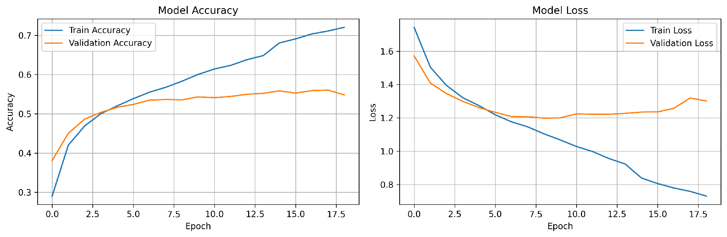

3.11 Model Performance Evaluation
The trained model was evaluated on the held-out FER-2013 test set of 7,178 images using standard classification metrics: accuracy, precision, recall, F1-score, and a confusion matrix. Overall, the model achieved an accuracy of 57.09%, with a weighted precision of 57.30%, a weighted recall of 57.09%, and a weighted F1-score of 56.57%. The macro-averaged F1-score was 51.44%, which is lower than the weighted score because of the weak performance on the small Disgust class. These results are consistent with the range typically reported for compact CNNs on this challenging dataset.
Table 3.6 reports the precision, recall, and F1-score for each emotion. The model performs best on Happy and Surprise, which are visually distinctive and well represented in the data, and worst on Disgust and Fear. Disgust suffers from having only 111 test images (and 436 training images), while Fear is frequently confused with Sad and Neutral. The confusion matrix in Figure 3.6 shows these patterns in detail.
Table 3.6: Per-Class Performance on the Test Set
Emotion | Precision (%) | Recall (%) | F1-Score (%) | Support
Angry | 49.4 | 47.8 | 48.6 | 958
Disgust | 79.2 | 17.1 | 28.1 | 111
Fear | 42.2 | 29.4 | 34.6 | 1,024
Happy | 76.7 | 79.6 | 78.1 | 1,774
Neutral | 49.6 | 60.6 | 54.5 | 1,233
Sad | 42.3 | 47.7 | 44.8 | 1,247
Surprise | 74.7 | 68.1 | 71.2 | 831
Macro Avg | 59.1 | 50.1 | 51.4 | 7,178
Weighted Avg | 57.3 | 57.1 | 56.6 | 7,178

Figure 3.6: Confusion Matrix on the FER-2013 Test Set
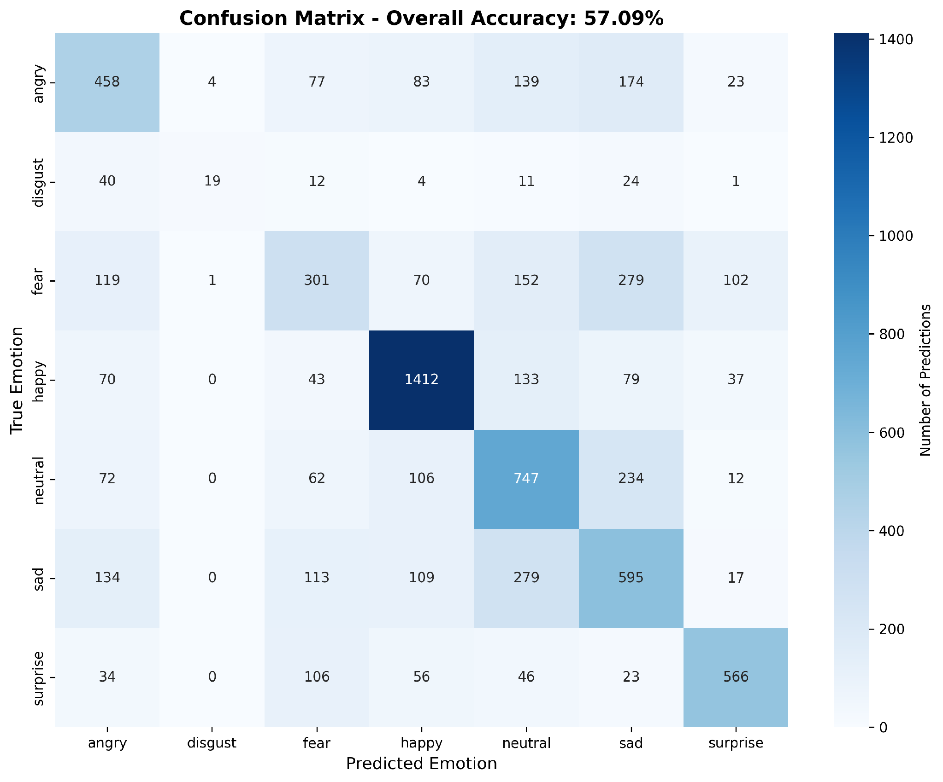

3.12 Testing and Evaluation
The completed system underwent functional and integration testing. Individual modules — face detection, model inference, the recommendation engine, the watchlist, and the mobile prediction endpoint — were tested before integration. Integration testing verified that the front-end, back-end, and model communicated correctly and that the live stream and status polling worked together without stalling. Interface testing checked navigation, responsiveness, and behaviour across different browsers. Particular attention was paid to camera lifecycle handling, ensuring that the webcam is released cleanly when a session ends or the tab is closed.

3.13 Deployment and Maintenance
MoodFlick is deployed as a Flask web application that users access through a browser, with the mobile companion connecting to the same server. The modular architecture makes maintenance and future enhancement straightforward. Regular maintenance activities include retraining the model with additional or augmented data, expanding the film catalogue, refining the emotion-to-mood mapping, and fixing any issues reported during use. The modular design ensures that such enhancements can be made without affecting the overall stability of the system.

CHAPTER 4 – RESULTS AND DISCUSSIONS

4.1 System Implementation
MoodFlick was successfully implemented as a web-based emotion recognition and film recommendation platform. The system integrates a Flask back-end, a trained CNN, OpenCV face detection, a responsive web front-end, and a React Native mobile companion. Together these components deliver real-time emotion recognition, transparent confidence reporting, and mood-based recommendations. The following sections present the main interfaces of the implemented system and the model performance results.

4.2 MoodFlick Home / Discover Interface
The home page is the entry point of the application. It introduces the platform, provides a prominent "Scan My Face" action, and offers manual mood, genre, and cast filters for users who prefer to browse without a scan. A shelf of all available films is shown by default. The interface uses a cinematic dark theme with animated transitions to create an engaging experience.
Figure 4.1: MoodFlick Home / Discover Interface
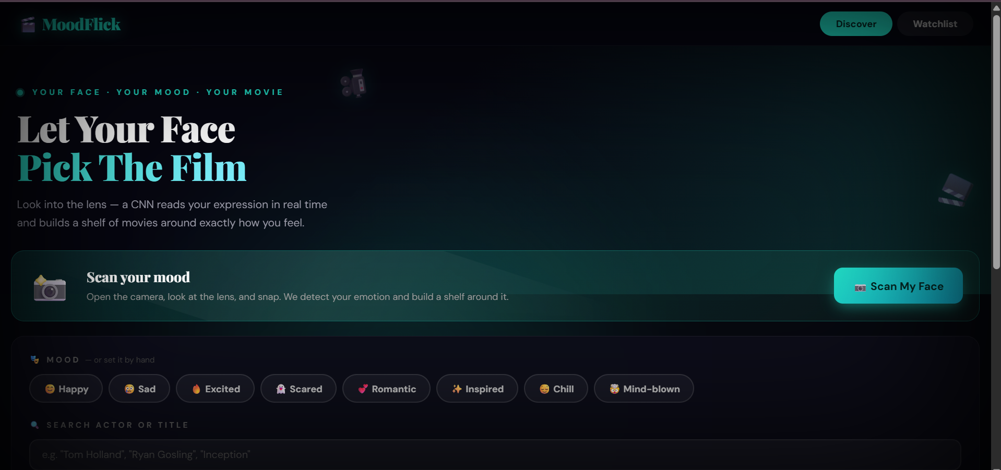

4.3 Live Emotion Detector Interface
The detector page provides a raw, continuous view of the emotion recognition engine. It shows the annotated live webcam feed alongside the current emotion, its emoji, the confidence value, and a bar for every class. This page is useful for demonstrating the model directly and for observing how predictions change as the user’s expression changes.
Figure 4.2: Live Emotion Detector Interface
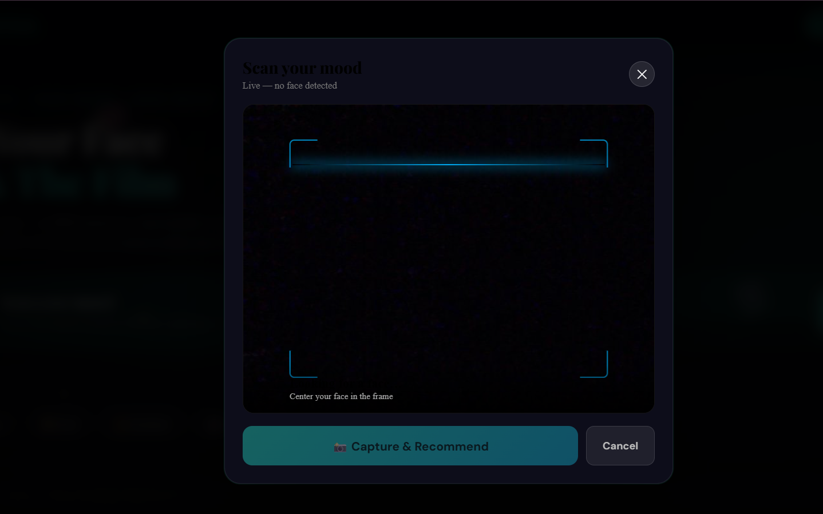

4.4 Face-Scan Camera Modal
When the user starts a scan, a camera modal opens, requests the webcam, and displays the live feed with a scanning overlay. Once a face is detected and an emotion is recognised, the capture button becomes active. The modal also handles error conditions gracefully, for example when the camera is unavailable or already in use by another application.
Figure 4.3: Face-Scan Camera Modal

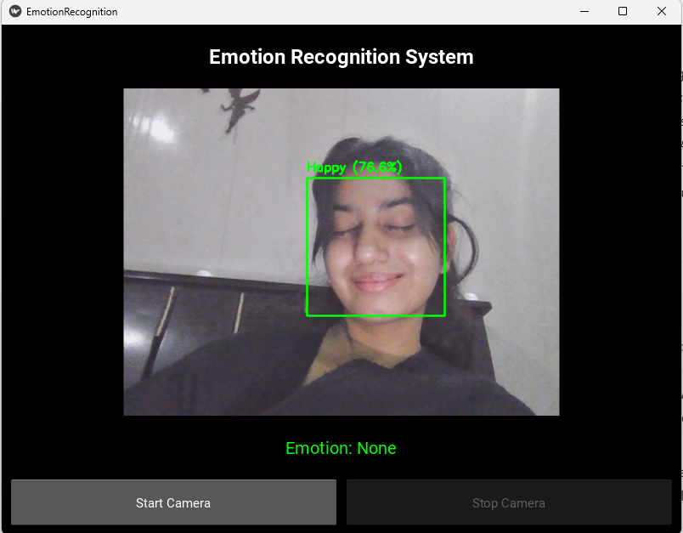

4.5 Detected Emotion and Confidence Breakdown
After a capture, the system displays the detected emotion together with its confidence and a message that reflects the mood. A model-breakdown panel shows the confidence for all seven classes, making the prediction transparent. This directly addresses the "black box" problem identified in the problem statement, allowing the user to judge how reliable the result is.

Figure 4.4: Detected Emotion and Confidence Breakdown

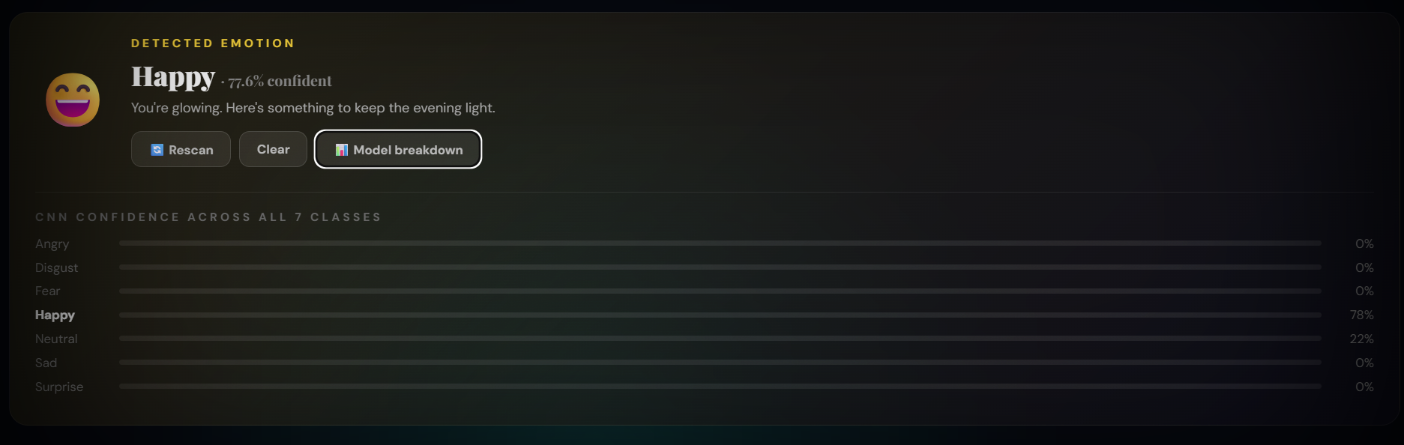

4.6 Mood-Based Movie Recommendations
Based on the detected emotion, MoodFlick builds recommendation shelves. A primary shelf presents films that match the user’s current mood, and a secondary shelf offers films that could shift the mood. The recommendations are ranked by rating and can be refined further using the genre filter or the search box.
Figure 4.5: Mood-Based Movie Recommendations
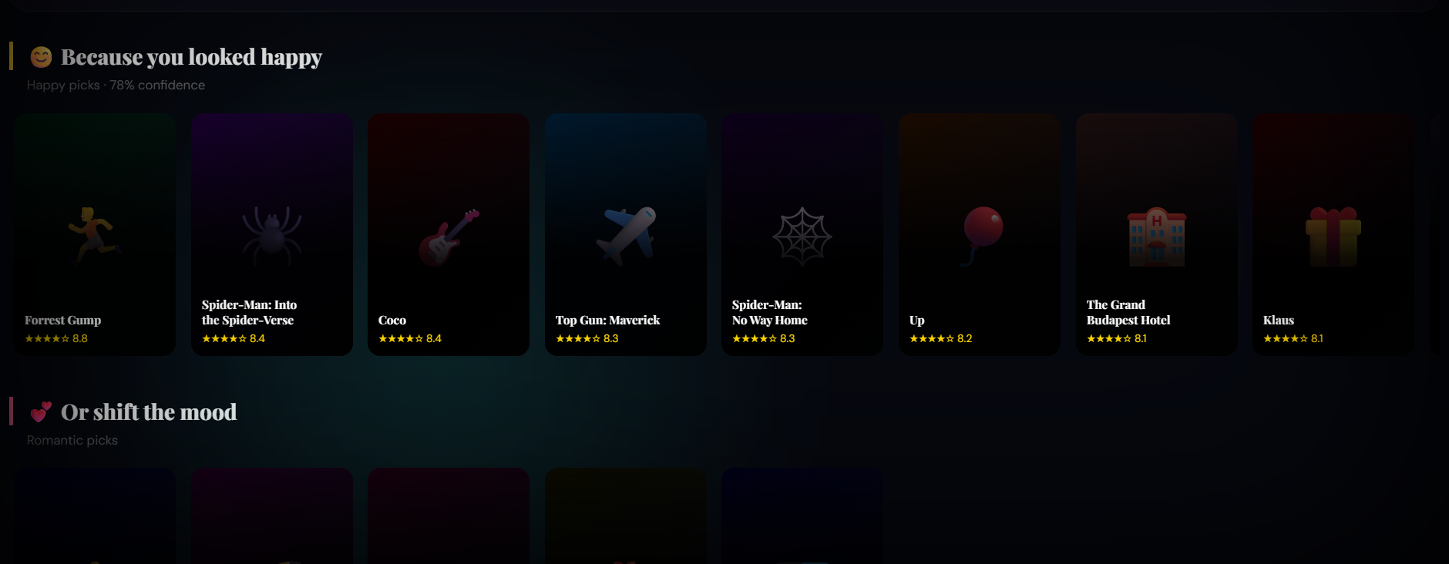

4.7 Movie Detail and Streaming Links
Selecting a film opens a detail view showing its rating, release year, overview, cast, and mood and genre tags. The view provides trailer and streaming search links so that the user can watch the film on an external platform, and a button to add the film to the watchlist.
Figure 4.6: Movie Detail and Streaming Links
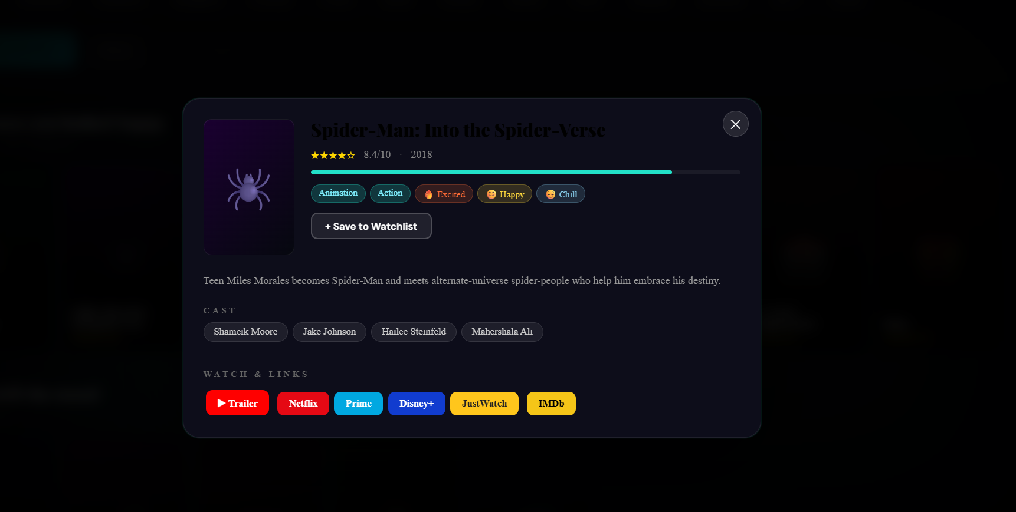

4.8 Watchlist Interface
The watchlist lets users collect films they wish to watch later. Films can be added or removed from any detail view, and a badge in the navigation bar shows the number of saved items. This gives the platform a sense of continuity beyond a single recommendation session.

Figure 4.7: Watchlist Interface


4.10 Model Performance Results
The performance of the emotion recognition model on the held-out test set of 7,178 images is summarised in Table 4.1. The model achieved an overall accuracy of 57.09% and a weighted F1-score of 56.57%. As discussed in Section 3.11, performance is strongest on the Happy and Surprise classes and weakest on the under-represented Disgust class.
Table 4.1: Overall Model Performance Metrics
Metric | Value
Test set size | 7,178 images
Accuracy | 57.09%
Precision (weighted) | 57.30%
Recall (weighted) | 57.09%
F1-Score (weighted) | 56.57%
F1-Score (macro) | 51.44%
Best class (F1) | Happy – 78.1%
Weakest class (F1) | Disgust – 28.1%

4.11 Discussion
The implementation of MoodFlick demonstrates the successful integration of deep learning, real-time computer vision, and modern web technologies into a single, engaging application. The CNN recognises facial emotions in real time, and the emotion-to-mood mapping turns each prediction into relevant film recommendations. The confidence breakdown keeps every prediction transparent, and the watchlist and mobile companion extend the experience beyond a single session.
The model’s accuracy of 57.09% reflects the well-known difficulty of the FER-2013 dataset, whose images are collected in uncontrolled conditions and whose classes are imbalanced. The strong results on Happy and Surprise, contrasted with the weak result on Disgust, are explained largely by class imbalance: Disgust has only 436 training images compared with more than 7,000 for Happy. The confusion matrix confirms that the most frequent errors occur among the visually similar negative emotions — Fear, Sad, and Angry.
Although the platform performs well as an interactive demonstration, it is intended for educational and research purposes and should not be used to draw conclusions about a person’s true emotional or mental state. Future improvements, discussed in the next chapter, include stronger network architectures, data augmentation to address class imbalance, integration with a live film database, and personalised recommendation.

CHAPTER 5 – CONCLUSION AND FUTURE WORK

5.1 Conclusion
This dissertation presented the design and development of MoodFlick, an emotion-based movie recommendation platform that combines facial emotion recognition with a mood-aware recommendation engine. Using a Convolutional Neural Network trained on the FER-2013 dataset, the system recognises one of seven emotions from a webcam frame or a captured photograph, maps that emotion to a viewing mood, and recommends films that match how the user feels.
Unlike conventional recommenders that rely only on viewing history, MoodFlick responds to the user’s current emotional state, and unlike opaque machine-learning demonstrations, it shows the confidence behind every prediction. The platform also provides a live emotion detector, a personal watchlist, streaming search links, forming a complete and engaging experience.
On the FER-2013 test set the model achieved an overall accuracy of 57.09% with a weighted F1-score of 56.57%, results that are consistent with those typically reported for compact CNNs on this challenging benchmark. The project successfully achieved the objectives defined at the outset and demonstrates how computer vision, deep learning, and modern web technologies can be integrated into an intelligent, transparent, and user-friendly product.

5.2 Limitations
Although MoodFlick meets its objectives, the project has several limitations.
The model was trained on the FER-2013 dataset, which contains low-resolution 48×48 grayscale images collected in uncontrolled conditions and suffers from class imbalance and label noise. As a result, the accuracy is moderate and the model performs poorly on the under-represented Disgust class.
The system recognises only seven basic emotions from a single frontal face and does not consider other signals of mood such as voice, text, or body language. Recognition accuracy can also degrade under poor lighting, extreme head poses, or occlusions such as glasses or masks.
The recommendation catalogue is curated and static rather than drawn from a live film database, and the recommendations are based on the emotion-to-mood mapping rather than on personalised user preferences. Finally, the platform is an academic prototype and is not intended for clinical or psychological use.

5.3 Future Work
Several enhancements can be implemented in future versions of MoodFlick to improve its accuracy, functionality, and usability.

Improved Model and Data
Stronger architectures such as deeper CNNs, VGG- or ResNet-style networks, or transfer learning from pre-trained face models could improve accuracy. Data augmentation and class-balancing techniques would help address the imbalance of the Disgust class, and training on larger or higher-resolution datasets would improve generalisation.

Live Film Database Integration
Connecting the recommendation engine to a live film database such as TMDB would replace the curated catalogue with an up-to-date library of films, complete with posters, ratings, and real-time streaming availability.

Personalised Recommendation
Combining the emotion-to-mood mapping with collaborative or content-based filtering and user profiles would allow MoodFlick to personalise recommendations over time, learning each user’s tastes in addition to their current mood.

Multimodal Emotion Recognition
Future work could combine facial expression with additional signals such as speech tone or text sentiment to produce a more robust estimate of mood, reducing the effect of ambiguous facial expressions.

Expanded Mobile Application and Cloud Deployment
The mobile companion could be extended into a full-featured application with live camera recognition, and the platform could be deployed on a cloud service to improve scalability, availability, and access for a larger number of users.

REFERENCES (IEEE STYLE)
[1] P. Ekman, "An argument for basic emotions," Cognition and Emotion, vol. 6, no. 3–4, pp. 169–200, 1992.
[2] I. J. Goodfellow et al., "Challenges in representation learning: A report on three machine learning contests," in Neural Information Processing, 2013, pp. 117–124.
[3] Y. LeCun, Y. Bengio, and G. Hinton, "Deep learning," Nature, vol. 521, no. 7553, pp. 436–444, 2015.
[4] I. Goodfellow, Y. Bengio, and A. Courville, Deep Learning. Cambridge, MA, USA: MIT Press, 2016.
[5] K. Simonyan and A. Zisserman, "Very deep convolutional networks for large-scale image recognition," in Proc. Int. Conf. Learn. Representations (ICLR), 2015.
[6] K. He, X. Zhang, S. Ren, and J. Sun, "Deep residual learning for image recognition," in Proc. IEEE Conf. Comput. Vis. Pattern Recognit. (CVPR), 2016, pp. 770–778.
[7] P. Viola and M. Jones, "Rapid object detection using a boosted cascade of simple features," in Proc. IEEE Conf. Comput. Vis. Pattern Recognit. (CVPR), 2001, pp. 511–518.
[8] G. Bradski, "The OpenCV Library," Dr. Dobb’s Journal of Software Tools, 2000.
[9] F. Chollet, Deep Learning with Python, 2nd ed. Shelter Island, NY, USA: Manning Publications, 2021.
[10] M. Abadi et al., "TensorFlow: A system for large-scale machine learning," in Proc. USENIX OSDI, 2016, pp. 265–283.
[11] F. Pedregosa et al., "Scikit-learn: Machine learning in Python," Journal of Machine Learning Research, vol. 12, pp. 2825–2830, 2011.
[12] Pallets Projects, Flask Documentation, 2024. [Online]. Available: https://flask.palletsprojects.com
[13] Meta Platforms, React Native Documentation, 2024. [Online]. Available: https://reactnative.dev
[14] F. Ricci, L. Rokach, and B. Shapira, Recommender Systems Handbook, 2nd ed. New York, NY, USA: Springer, 2015.
[15] M. Soleymani, M. Pantic, and T. Pun, "Multimodal emotion recognition in response to videos," IEEE Trans. Affective Computing, vol. 3, no. 2, pp. 211–223, 2012.

